|  |  |  |  |
| --- | --- | --- | --- |
| **Date:** | **03-06-2020** | **Name:** | **Rohan Shetty** |
| **Course:** | **Digital Design Using HDL** | **USN:** | **4al17ec079** |
| **Topic:** | **EDA Playground Online compiler, EDA Playground Tutorial Demo Video**  **How to Download and Install Xilinx Vivado Design Suite,**  **Task for Day-3** | **Semester & Section:** | **6th & ‘B’** |
| **GitHub**  **Repository:** | **rohan-shetty-online-courses** |  |  |

|  |
| --- |
| FORENOON SESSION DETAILS |
| Image of session |
|  |

|  |
| --- |
| **Implement Inverter Using The EDA Tool:**  module inverter(y,a); output y;  input a; assign y=~a; endmodule  module testbench(); reg a1;  wire y1;  inverter inv1(a1,y1); initial begin  a1=a’b1;  $display(“a=%b”,a1);  end endmodule  2.RCC: A ripple counter is an asynchronous counter where only the first flip-flop is clocked by an external clock. All subsequent flip-flops are clocked by the output of the preceding flip-flop. Asynchronous counters are also called ripple-counters because of the way the clock pulse ripples it way through the flip-flops.  Ripple Carry Counter  module ripple_counter_4_bit(q,clk,reset); input clk,reset;  output[3:0]q;  T_FF tff0(q[0],clk,reset); T_FF tff1(q[1],q[0],reset);  T_FF tff2(q[2],q[1],reset);  T_FF tff3(q[3],q[2],reset); endmodule  module T_FF(q,clk,reset); input clk,reset;  output q; wire d;  D_FF dff0(q,d,clk,reset); not n1(d,q);  endmodule  module D_FF(q,d,clk,reset); input d,clk,reset;  output reg q;  always@(negedge clk or posedge reset) begin  if(reset) q<=1'b0;  else q<=d; end  endmodule  **TestBench Code:**  module test  reg clk,reset; wire(3:0)q;  ripple_carry_counter rcc(q,clk,reset);  initial begin  $dumpvars(1,test); clk=1’b0; reset=1’b1;  #10 reset=1’b0;  #200;  end  always #5 clk=~clk; endmodule |

# 

Implement 4 to 1 MUX using structural modelling style and test the module in an online/offline compiler.

library IEEE;

use IEEE.STD_LOGIC_1164.ALL;

entity mux2_1 is

port(A,B : in STD_LOGIC; S: in STD_LOGIC;

Z: out STD_LOGIC);

end mux2_1;

architecture Behavioral of mux2_1 is begin

process (A,B,S) is begin

if (S ='0') then Z <= A;

else

Z <= B;

end if; end process;

end behavioral;

library IEEE;

use IEEE.STD_LOGIC_1164.ALL;

entity mux4_1 is port(

A,B,C,D : in STD_LOGIC; S0,S1: in STD_LOGIC; Z: out STD_LOGIC

);

end mux4_1;

architecture Behavioral of mux4_1 is component mux2_1

port( A,B : in STD_LOGIC; S: in STD_LOGIC;

Z: out STD_LOGIC);

end component;

signal temp1, temp2: std_logic; begin

m1: mux2_1 port map(A,B,S0,temp1); m2: mux2_1 port map(C,D,S0,temp2); m3: mux2_1 port map(temp1,temp2,S1,Z);

end behavioral;

ld a Web-based Financial Graph

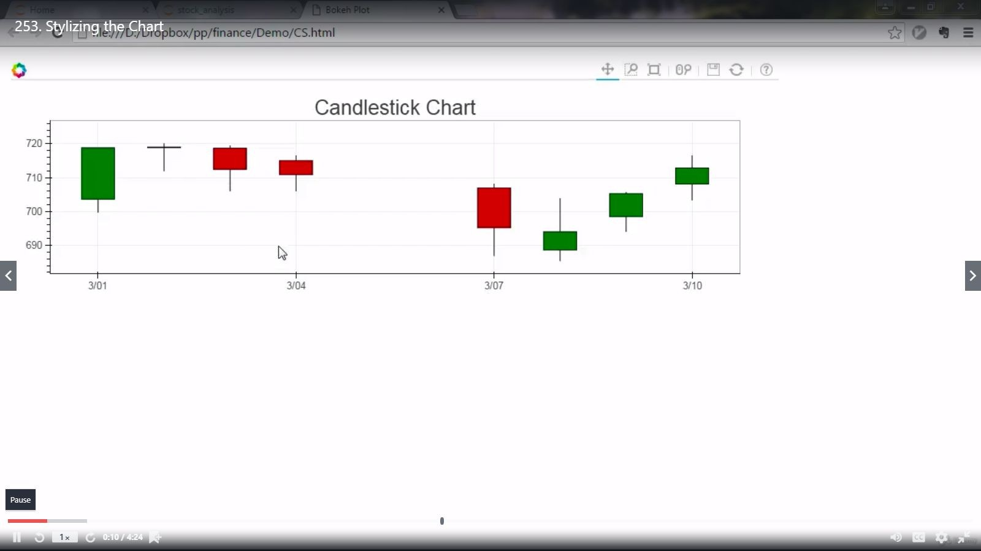

**Image of session:Output**

**AFTERNOON SESSION DETAILS**

from flask import Flask, render_template app=Flask( name )

@app.route('/plot/') def plot():

from pandas_datareader import data import datetime

import fix_yahoo_finance as yf yf.pdr_override()

from bokeh.plotting import figure, show, output_file from bokeh.embed import components

from bokeh.resources import CDN

start=datetime.datetime(2015,11,1) end=datetime.datetime(2016,3,10)

df=data.get_data_yahoo(tickers="GOOG", start=start, end=end)

def inc_dec(c, o): if c > o:

value="Increase" elif c < o:

value="Decrease" else:

value="Equal" return value

df["Status"]=[inc_dec(c,o) for c, o in zip(df.Close,df.Open)] df["Middle"]=(df.Open+df.Close)/2

df["Height"]=abs(df.Close-df.Open)

p=figure(x_axis_type='datetime', width=1000, height=300) p.title.text="Candlestick Chart" p.grid.grid_line_alpha=0.3

hours_12=12*60*60*1000



p.segment(df.index, df.High, df.index, df.Low, color="Black")

p.rect(df.index[df.Status=="Increase"],df.Middle[df.Status=="Increase"], hours_12,

df.Height[df.Status=="Increase"],fill_color="#CCFFFF",line_color="black")

p.rect(df.index[df.Status=="Decrease"],df.Middle[df.Status=="Decrease"], hours_12,

df.Height[df.Status=="Decrease"],fill_color="#FF3333",line_color="black")

script1, div1 = components(p) cdn_js=CDN.js_files[0] cdn_css=CDN.css_files[0]

return render_template("plot.html", script1=script1,

div1=div1, cdn_css=cdn_css, cdn_js=cdn_js )

@app.route('/') def home():

return render_template("home.html")

@app.route('/about/') def about():

return render_template("about.html")

if name ==" main ": app.run(debug=True)